Print Demo User Manual

Manual Name：Print Demo User Manual
Manual NO ：
Version：V1.0

Total 11 pages
(Including cover)

Compose ZhangYong
Review
Countersign

Cilico Microelectronics Co., Ltd
Modifiy record
File No. | Version | Composed By / Modified By | Compose / Modify Date | Modify Reason | Major changes  （Write main Points） | Review By
 | V1.0 | ZhangYong | 2017.03.27 | / | / | ShiLiangYi
Note: When the file is prepared for the first time, write “None” on "Modify Reason" and "Major modifications columns.

Contents

1. Purpose 4
2. Applicable scope 4
3. Install APK 4
4. Launcher App 4
5. Print check 5
6. DIY Print 5
6.1 introduce 6
6.2 print 1d barcode 7
6.3 print 2d barcode 8
6.4 print text 9
7. Web call print 10
8. Help 11

1 Purpose
Introduce the functionality and interface of the App, guide the user how to use this APP to test print function,customize print and test web page call print.
2 Applicable scope
Adapter to PDA ,which supports print function.
3 Install APK
First ensure that the device support print function, Then check whether the device had install this APP, if it was not installed，so install PrintChecker.apk。
4 Launcher APP
Click the NFC APP Icon to launcher it. 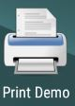
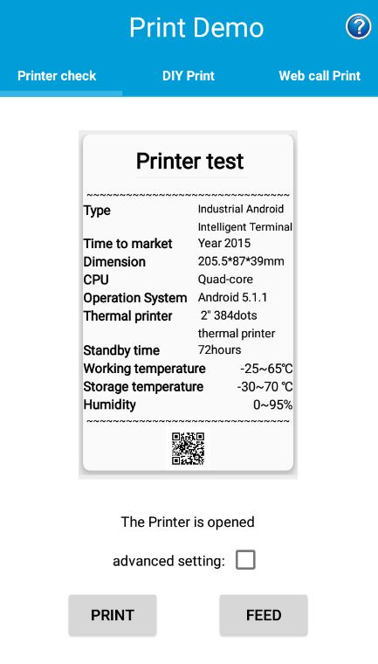
5 Print check
5.1 Introduce
This function is mainly used to demonstrate the printing of a list of device information containing text and 2d barcodcode. In advanced settings, support for custom title text attributes, such as bold, font size, alignment, print grayscale, and so on..
5.2 One key print
Click the "Print" button in the bottom left corner to print out the list of device information. Click the "FEED" button to adjust the starting position of the next print.
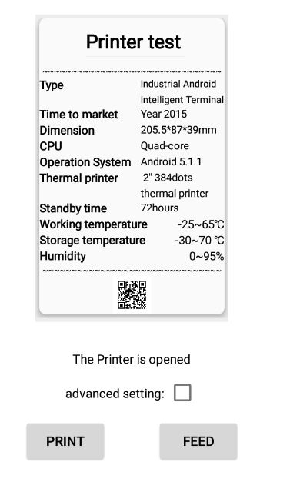
5.3 Advance Print
Select the "Advanced settings" checkbox,then you can edit the title text, modify the relevant properties, set the print grayscale, and turn the print service on or off.

6 customize print
6.1 Introduce
This feature supports print one-dimensional code, two-dimensional code and text on labels and non-label paper .
In the advanced function, you can set the one-dimensional code and two-dimensional code width , height and barcode format, you can modify the text of the property. Also, you can set the print area height, set the print grayscale, and set the number of printed pages。
Note: Because there is a interval between every page of label paper, so it divided to print the label and non-label paper , you can operate the "label paper" option to control which category paper will be printed on , the default print on non-label paper.
6.2 Print 1d barcode
In the edit box, input the one-dimensional code information, at the top of the interface, the default generation of one-dimensional barcode preview. Click the "Print" button in the bottom left corner to print out the one-dimensional barcode。
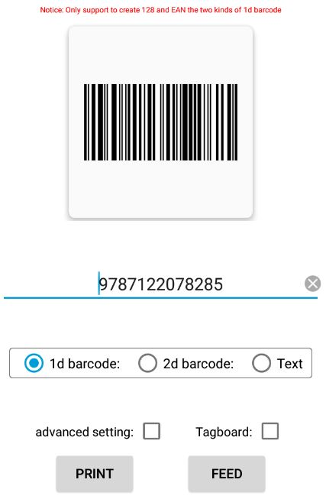
Open the advanced function, in the upper right corner to modify the width of the one-dimensional code, select the one-dimensional barcode category, and finally click the "Save Settings" button.The left preview will auto regenerate.
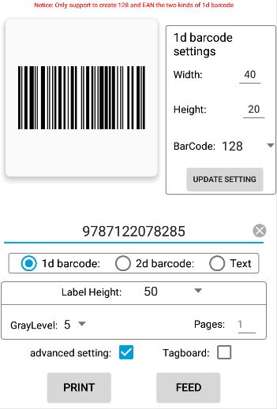
6.3 Print 2d barcode
In the edit box, input the two-dimensional code information.at the top of the interface, the default generation of QR code two-dimensional code preview. Click the "Print" button in the bottom left corner to print out the two-dimensional code.
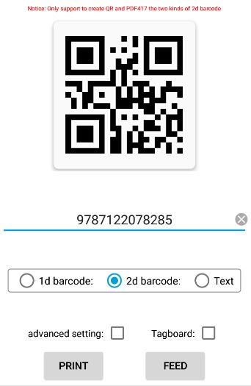

Open the advanced features, in the upper right corner to modify the width of the two-dimensional code, select the category of two-dimensional code , and finally click the "Save Settings" button, then the left preview will auto regenerate.
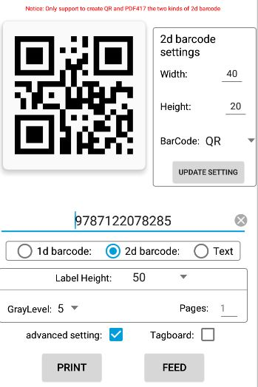
6.4 Print Text
In the edit box, input the text information, at the top of the interface, will generate a preview. Click the "Print" button in the lower left corner to print out the text message.
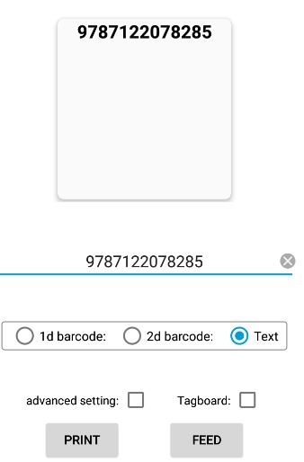
Open the advanced features, modify the text attributes in the upper right corner, and finally click the "Save Settings" button, then the left preview will auto regenerate.
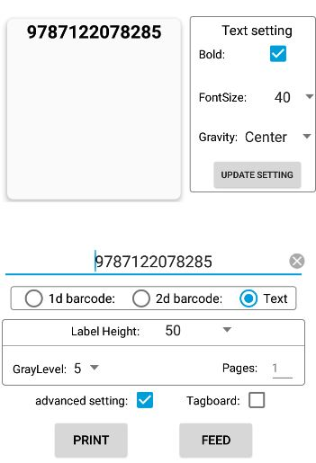
7 web file call Print
7.1 Introduce
This function is mainly used to demonstrate web pages call the print device, at default it will load the web file which the path is "assets/print_en.html".
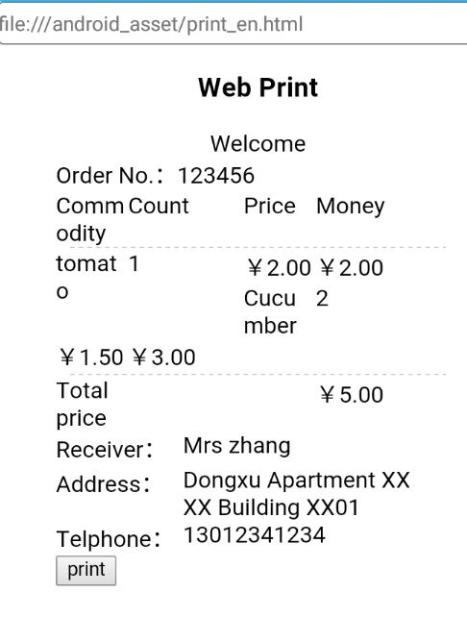
8 Help
Click on the upper right corner of the icon, enter into the help interface, which describes the basic information of the print function, as well as some operating instructions.

